IWMD REPORT 2018.
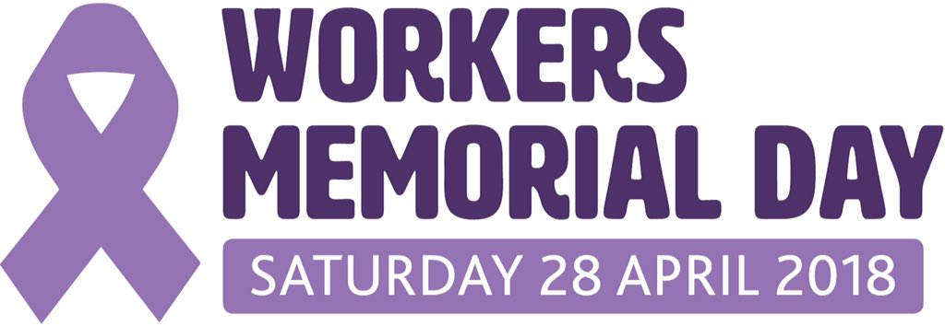
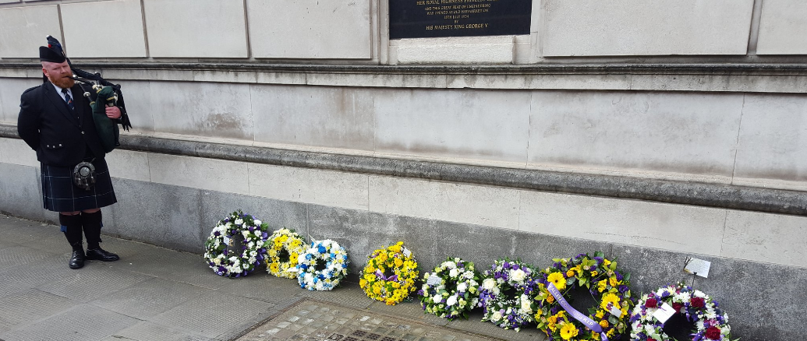
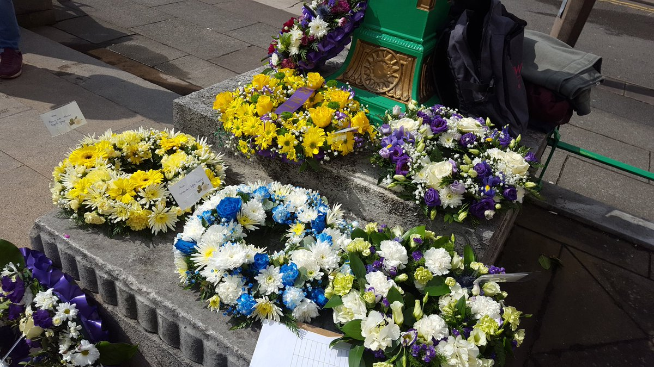
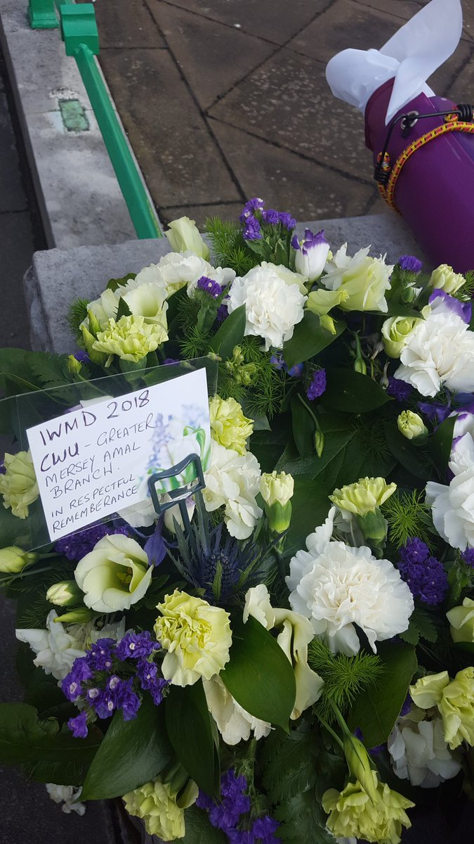

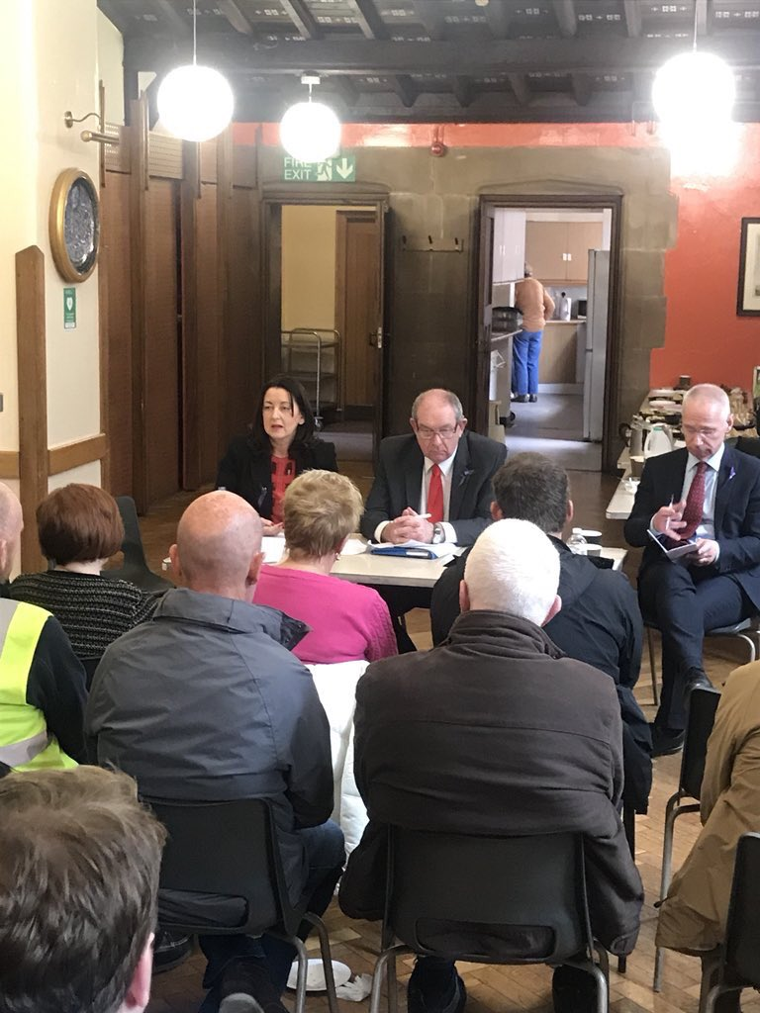
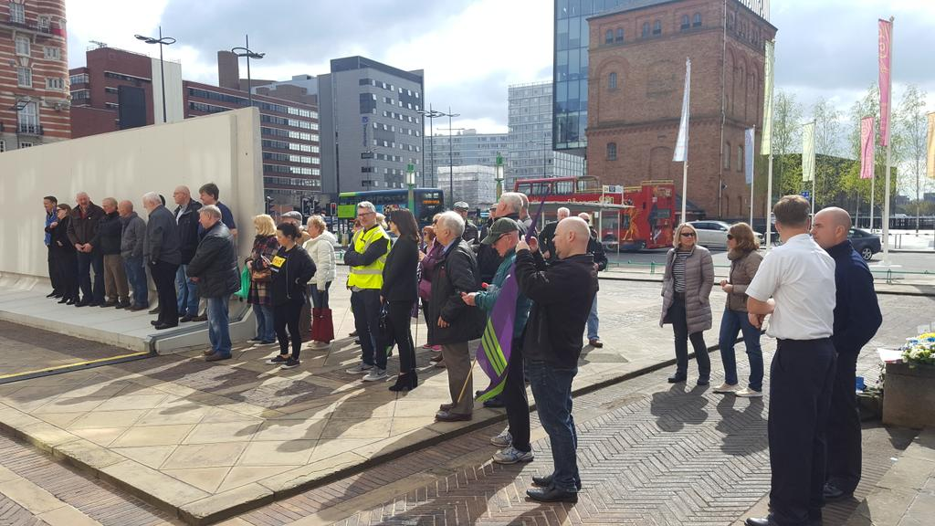
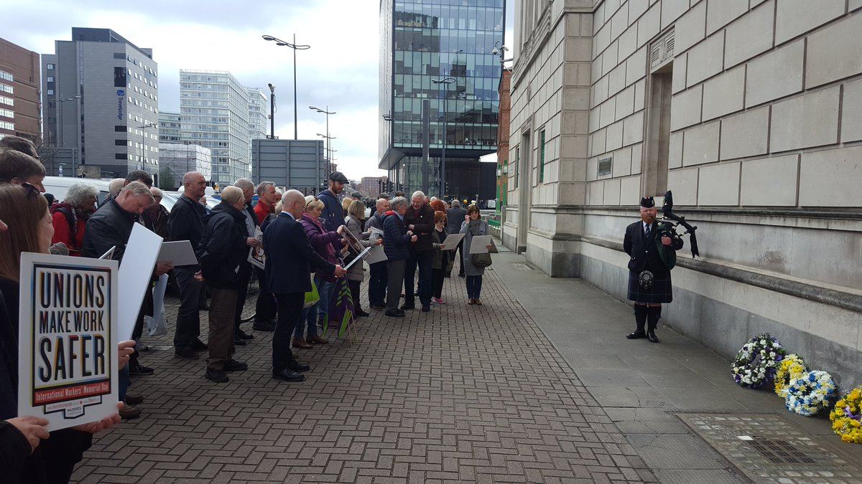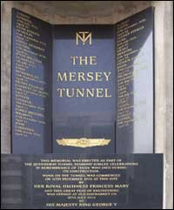
Merseyside IWMD 2018 was a solemn & sombre day with respect and remembrance and commemoration taking place at the Mersey Tunnel workers memorial.
17 men died during the construction of the tunnel.
This memorial was erected as part of the Queensway Tunnel Diamond Jubilee Celebrations in remembrance of those who died during its construction.
This year’s memorial day included special invited guests from TYRED campaign, how apt the motto of IWMD is 'Remember the dead and fight for the living' This is something Frances Molloy exemplifies and epitomises with indomitable spirit
When she speaks everyone listens it seems EXCEPT for the Government!
The ceremony took place at St Georges Piazza and then moved to St Nicholas church (off chapel street) where invited speakers addressed those who gathered.
Darren Pillage from RMT spoke powerfully and candidly about the challenges their union face and the battle over the ‘keep the guards on the train’ long running campaign and also about the safety history in the UK relating to catastrophic failures on the rail systems covering all parts of the UK .
Matt Tollitt spoke from Thompson’s solicitors spoke about the increased difficulties which have arisen since the strict liability rules came into force.
His firm of solicitors will continue to robustly defend any member who has been injured in work or fallen ill because of work. If he had one wish, it would be to reverse the recent imposition of amendments to acts making life extremely difficult for trade unions and worker organisations.
Frances Molloy spoke about the 2012 coach crash which resulted in 3 lives being lost, with one being her son Michael who was just 18 years old. The coach transporting young people back from a music festival crashed, causing three people to tragically lose their lives, with many more suffering life changing injuries.
The crash was caused by a tyre that was 19.5 years old!
Following an inquest into this tragic crash, the coroner wrote to the government appealing for legislation to be brought to ban tyres over 10 years old from being used on coaches, buses and mini buses.
The department of transport did not implement any change in legislation but simply amended the safety guidelines for public service vehicles by only recommending tyres over 10 years old should not be fitted.
THIS IS NOT ENOUGH. Unless legislation is passed it is impossible to enforce tyre age limit rules and people sadly WILL be killed and injured due to old tyres.
Frances remains resolute despite the continuing opposition from government to the Tyred bill. Her address at IWMD 2018 was both powerful & moving. When Frances stopped speaking a lady representing the church came over to hug her, it was incredibly moving. I think I was that emotion and a moment that summed up what everyone was thinking.
WE ARE WITH YOU!

